MEASURING DISTANCES TO STARS

Close Stars

• Parallax method is used.
• Stars are observed 6 months apart.
• Close stars appear to move but distant stars do not.
• Trigonometry is used to calculate the distance.

Earth
star
Angle (θ) of star to the line at right angles to the base line.
Sun
Distance = 1 astronomical unit (AU) = 149,597,870,700 m.
Distance (x) to the star.

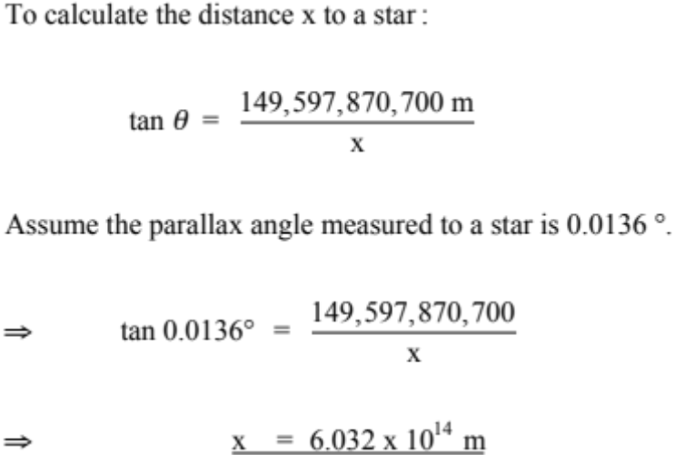

• The parsec (pc) is used as a measure of intergalactic distances.
• Using the above calculation, with parallax angle  = 1.0 second of arc (1/3600 °):

1.00 parsec = 3.085678 x 10¹⁶ m = 3.261564 light years
Distant Stars

• Distant stars do not appear to move very much when viewed by parallax method.
• The apparent brightness of the stars is used to measure their distances.
• Cepheid variables vary in brightness over a set period of time and are used to estimate distances to galaxies.

